YN  AGE: 9-16  KIT: STICKS ARE AVAILABLE, SHINPADS MUST BE WORN, GUM SHIELDS ARE HIGHLY ADVISABLE.  LUNCH: BRING PACKED LUNCH.  TIME:10am -3pm.  COST  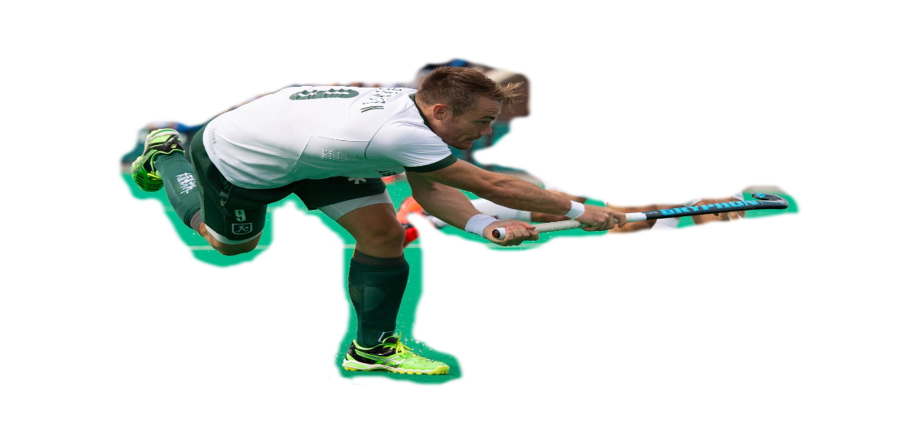  £35 PER DAY  £60 FOR TWO  £80 FOR THREE  SIMON EGERTON  ENGLAND &  GREAT BRITAIN | hockey coaching @ ABBEYGATE COLLEGE  MONDAY 18TH, tUESDAY 19TH, WEDNESDAY 20th FEBRUARY  Saighton lane, saighton, chester, ch3 6en  ALL COACHES ARE FULLY QUALIFIED AND CRB CHECKED  FOR MORE INFORMANTION ABOUT BOOKING ON THE COURSE PLEASE CONTACT:  SIRUSCOACHING@HOTMAIL.CO.UK  prizes  SPECIALIST GOALKEEPER COACHING  GRYPHON STICKS, STICKBAGS AND OTHER PRIZES  ALL ABILITIES WELCOME  FANTASTIC OPPORTUNITY TO BE COACHED BY ENGLAND AND GREAT BRITAIN HOCKEY PLAYERS. LEARNING NEW SKILLS WITH SPECIALIST TRAINING.

@SIRUSCOACHING SIRUSCOACHING@HOTMAIL.CO.UK
FEBRUARY 2019

Surname: ______________________________________________________________
Forename: ______________________________________________________________
Age: ____________________
Address: ______________________________________________________________
_________________________________________________________________________
Post Code: _____________________
Emergency Tel.No: _______________________________________________________
School/Club: _____________________________________________________________
Please let us know of any medical issues we need to be aware of (e.g. Asthma): _________________________________________________________________________
_________________________________________________________________________
Preferred playing position: _________________________________

Signed: _______________________________________________ [Parent/Guardian]

Method of payment: (Please make cheques payable to “SIRUSCOACHING”)
Cheque:
Cash:

In line with GDPR, any information provided will be destroyed following the conclusion of the course

@SIRUSCOACHING SIRUSCOACHING@HOTMAIL.CO.UK

